***Assessment Chapter 4,5***

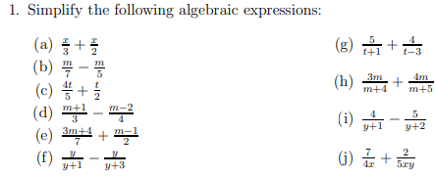

Q: 2 Expand and simplify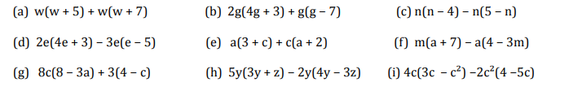

Q: 3 Explain the rule and find next three terms .

