**Organic chemistry**

**Fuels**

1  Name the fossil fuels: coal, natural gas and petroleum

2  Name methane as the main constituent of natural gas

3  State that hydrocarbons are compounds that contain hydrogen and carbon *only*

4  State that petroleum is a mixture of hydrocarbons

5  Describe the separation of petroleum into useful fractions by fractional distillation

6  Describe how the properties of fractions obtained from petroleum change from the bottom to the top of the fractionating column, limited to:

(a)  decreasing chain length



(b)  higher volatility (easily evaporated)

(c)  lower boiling points

(d)  lower viscosity (sticky, adhesiveness)

7 Name the uses of the fractions as:

(a)  refinery gas fraction for gas used in heating and cooking

(b)  gasoline / petrol fraction for fuel used in cars

(c)  naphtha fraction as a chemical feedstock

(d)  kerosene / paraffin fraction for jet fuel

(e)  diesel oil / gas oil fraction for fuel used in diesel engines

(f)  fuel oil fraction for fuel used in ships and home heating systems

(g)  lubricating oil fraction for lubricants, waxes and polishes

(h)  bitumen fraction for making roads

**Formulae, functional groups and terminology**

1  Draw and interpret the displayed formula of a molecule to show all the atoms and all the bonds

2  Write and interpret general formulae of compounds in the same homologous series, limited to:

(a) alkanes,C*n*H2*n*+2  
(b) alkenes, C*n*H2*n*(c) alcohols,C*n*H2*n*+1OH  
(d) carboxylic acids, C*n*H2*n*+1COOH

3  Identify a functional group as an atom or group of atoms that determine the chemical properties of a homologous series

4  State that a homologous series is a family of similar compounds with similar chemical properties due to the presence of the same functional group

5  State that a saturated compound has molecules in which all carbon–carbon bonds are single bonds

6  State that an unsaturated compound has molecules in which one or more carbon–carbon bonds are not single bonds

7  State that a structural formula is an unambiguous description of the way the atoms in a molecule are arranged, including CH2=CH2, CH3CH2OH, CH3COOCH3

8  Define structural isomers as compounds with the same molecular formula, but different structural formulae, including C4H10 as CH3CH2CH2CH3 and CH3CH(CH3)CH3 and C4H8 as CH3CH2CH=CH2 and CH3CH=CHCH3

9 Describe the general characteristics of a homologous series as:

(a)  having the same functional group

(b)  having the same general formula

(c)  differing from one member to the next by a –CH2– unit

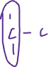

(d)  displaying a trend in physical properties

(e)  sharing similar chemical properties

**Naming organic compounds**

1  Name and draw the displayed formulae of:

(a)  methane and ethane

(b)  ethene

(c)  ethanol

(d)  ethanoic acid

(e)  the products of the reactions stated in sections 11.4–11.7

2  State the type of compound present, given a chemical name ending in -ane, -ene, -ol, or -oic acid or from a molecular formula or displayed formula

3 Name and draw the structural and displayed formulae of unbranched:

(a)  alkanes

(b)  alkenes, including but-1-ene and but-2-ene

(c)  alcohols,including  
propan-1-ol, propan-2-ol, butan-1-ol and butan-2-ol

(d)  carboxylic acids

containing up to four carbon atoms per molecule

4 Name and draw the displayed formulae of the unbranched esters which can be made from unbranched alcohols and carboxylic acids, each containing up to four carbon atoms

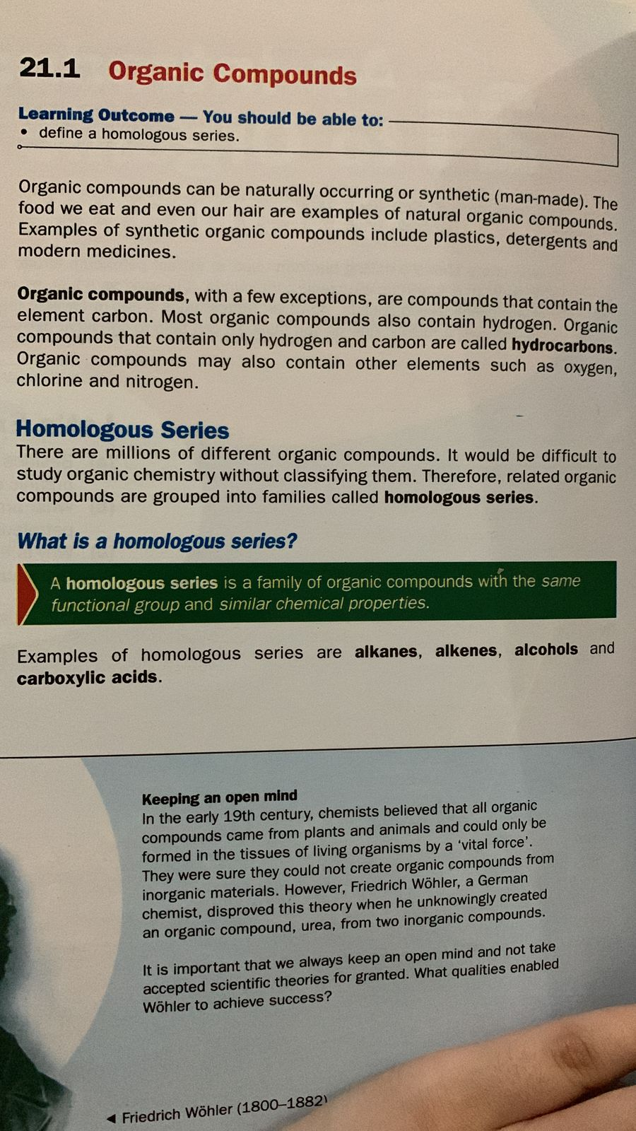



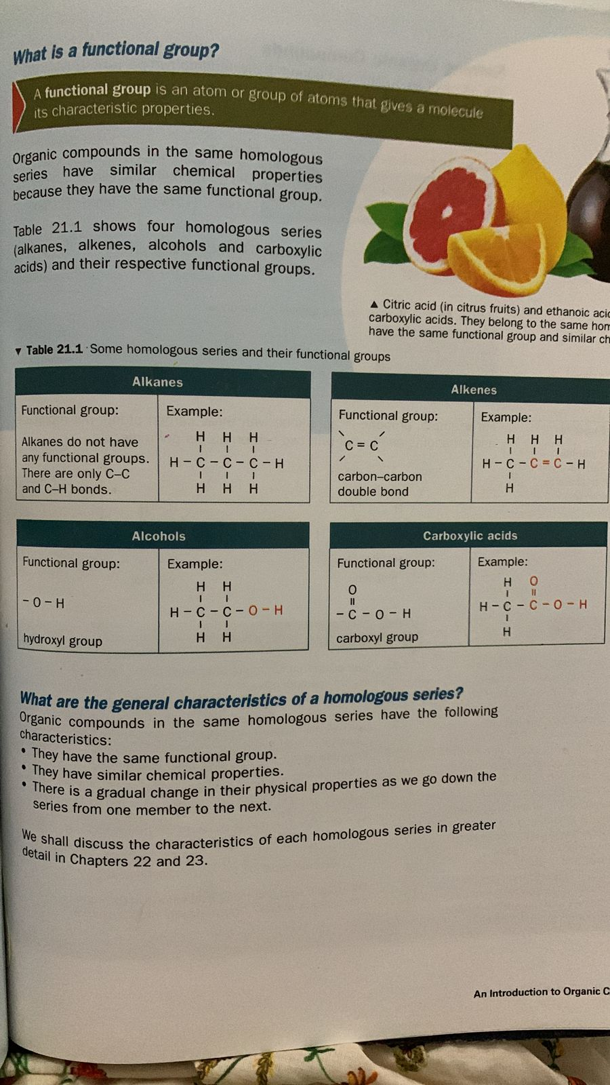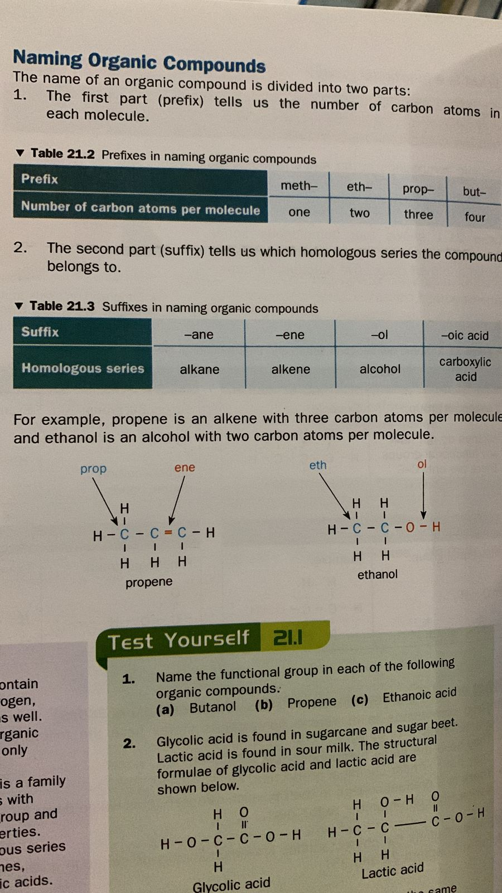2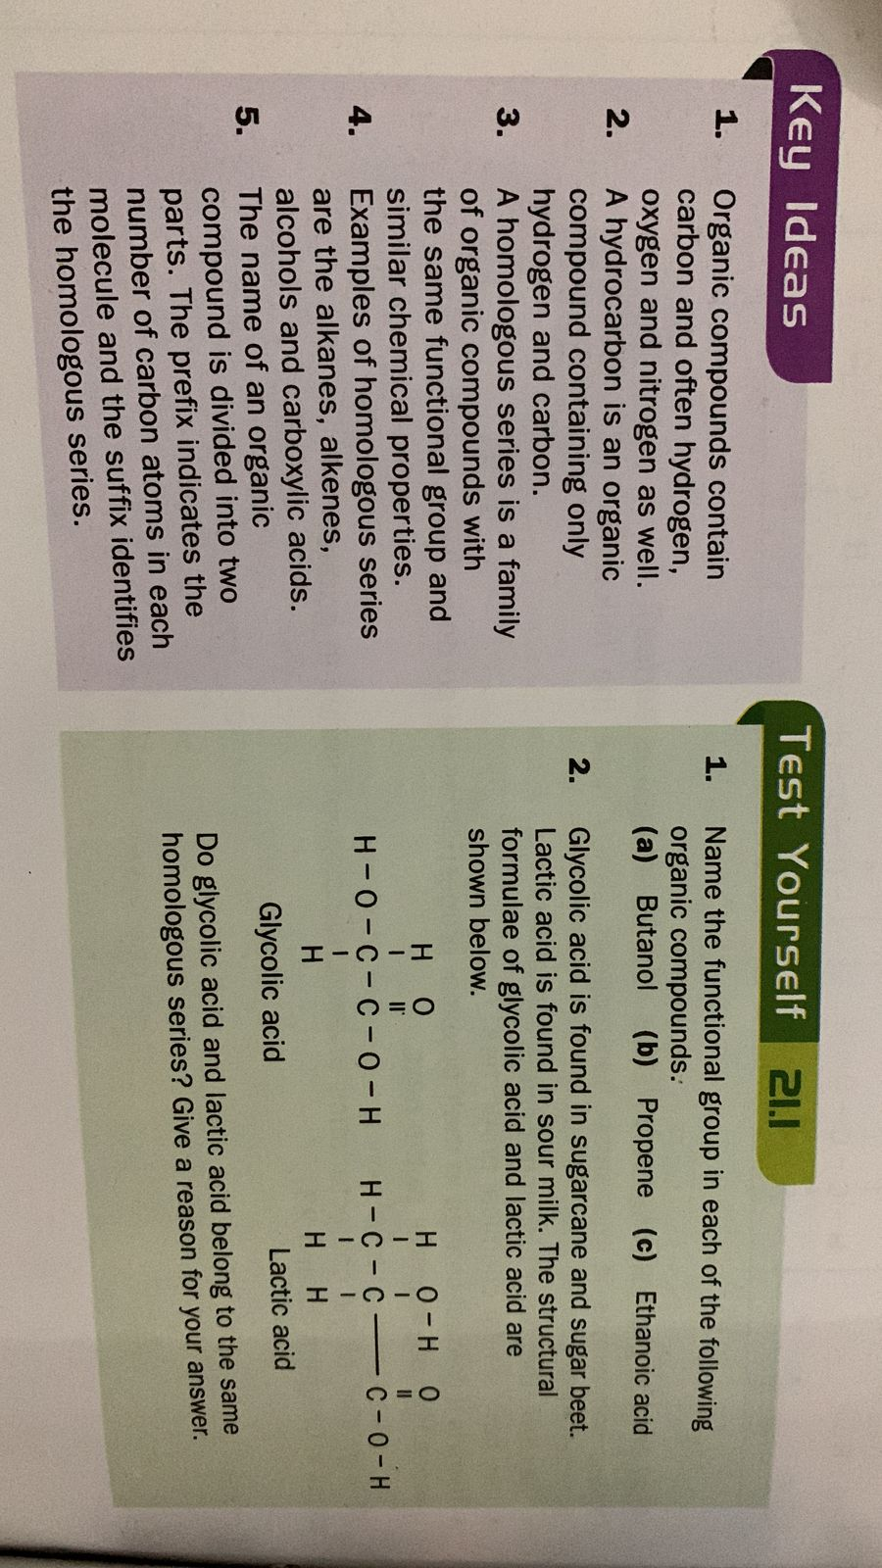



2-methylpropane CH3CH(CH3)CH3

