Acid: a substance that dissolves in water, producing H+(aq) ions - a solution of an acid turns litmus red and has a pH below 7.
Acids act as proton donors.

corrosive: a corrosive substance (e.g. an acid) is one that can dissolve or 'eat away' at other materials (e.g. wood, metals or human skin)

base: proton acceptors, a substance that neutralises an acid, producing a salt and water as the only products. Bases act as proton acceptors.

alkalis: proton acceptors, soluble bases that produce OH-(aq) ions in water - a solution of an alkali turns litmus blue and has a pH above 7.

neutralisation: a chemical reaction between an acid and a base to produce a salt and water only; summarised by the ionic equation H⁺(aq) + OH⁻(aq) = H₂0(l)

Acids:
Metal oxides and non-metal oxides
solutions contain an excess of H* ions and have a pH lower than 7.0
turn blue litmus red
are neutralised by a base to give a salt and water only.

Bases:
Are the oxides and hydroxides of metals
neutralise acids to give a salt and water only
are mainly insoluble in water
pH greater than 7

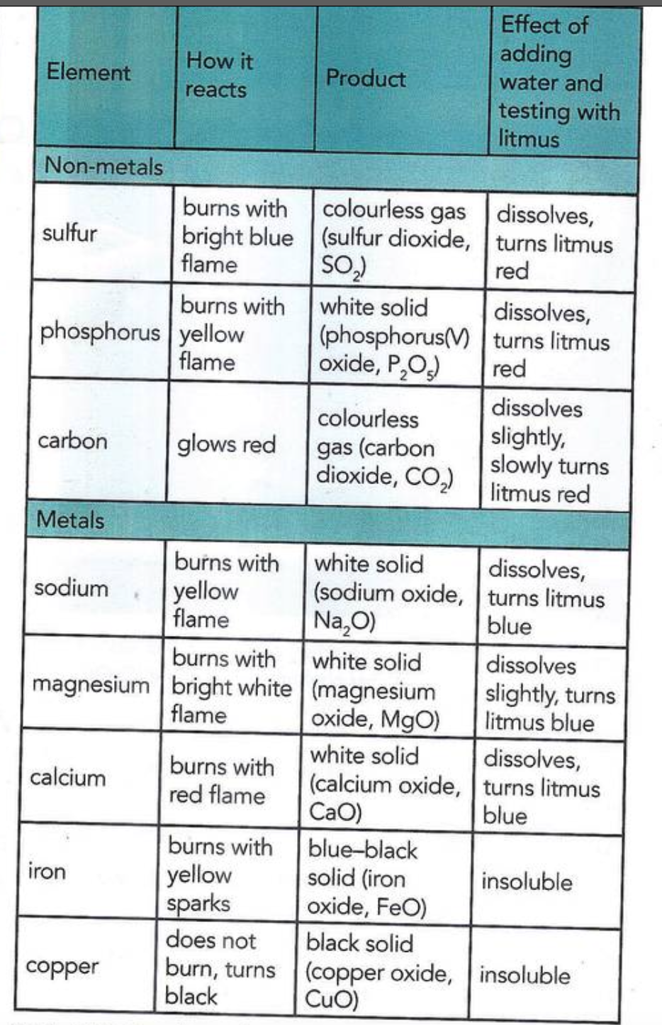

acidic oxides: of non-metals that will react with bases and dissolve in water to produce acid solutions.

basic oxides: oxide of a metal that will react with acids to neutralize the acid.
amphoteric compound: a compound (hydroxide or metal oxide) that reacts with both an acid and an alkali to give a salt and water.

metal + acid = salt + hydrogen

acid + base/alkali = salt + water

acid + metal carbonate salt + water +carbon dioxide

dissociation: the separation of a covalent molecule into ions when dissolved in water.

strong acid: an acid that is completely ionized when dissolved in water - this produces the highest possible concentration of H*(aq) ions in solution, e.g. hydrochloric acid

weak acid: an acid that is only partially dissociated into ions in water - usually this
produces a low concentration of H*(ag) in the solution, e.g. ethanoic acid

Preparation of Salts

salts: ionic compounds made by the neutralization of an acid with a base (or alkali), e.g. copper (Il) sulfate and potassium nitrate.

soluble: a solute that dissolves in a particular solvent.

insoluble: a substance that does not dissolve in a particular solvent.

hydrated substance: a substance that is chemically combined with water; hydrated salts are an important group of such substances.

anhydrous: without water combined with it

