**10 Chemistry of the environment**

**10.1 Water**

1. Describe chemical tests for the presence of water using anhydrous cobalt(II) chloride and anhydrous copper(II) sulfate

Anhydrous copper(II) sulfate turns from white to blue when water is added. Anhydrous cobalt(II) chloride turns from blue to pink when water in an aqueous solution is added.

1. Describe how to test for the purity of water using melting point and boiling point

Every pure substance has its own particular melting point and boiling point. One way to check the purity of the separated liquid is to measure its boiling point. For example, pure water boils at 100 oC. If it contains any dissolved solids, its boiling point will be higher than this. Pure water melts at greater than 0oC and room temperature and pressure. Freezes at 0oC.

1. Distilled water is used in practical chemistry rather than tap water because it contains fewer chemical impurities

Water that has been boiled into vapor and condensed back into liquid in a separate container. It is pure water.

1. State that water from natural sources (e.g., rain, ground water, river, oceans, lakes, waterfalls) may contain substances, including:

(a)  dissolved oxygen

(b)  metal compounds

(c)  plastics

(d)  sewage

(e)  harmful microbes

(f)  nitrates from fertilisers

(g)  phosphates from fertilisers and detergents

1. State that some of these substances are beneficial, including:

(a)  dissolved oxygen for aquatic life

(b)  some metal compounds provide essential minerals for life

1. State that some of these substances are potentially harmful, including:

(a)  some metal compounds are toxic e.g., copper, nickel, zinc, cadmium

(b)  some plastics harm aquatic life e.g., ingestion, suffocation, entanglement of marine species

(c)  sewage contains harmful microbes which cause disease (pollutes the sea, oxygen depletion, may cause harm if consumed by humans)

(d)  nitrates and phosphates lead to deoxygenation of water and damage to aquatic life

1. Describe the treatment of the domestic water supply (drinking, washing, cooking) in terms of:

(a)  sedimentation (decantation, deposition of insoluble solids) and filtration to remove solids

(b)  use of carbon to remove tastes and odours

(c)  chlorination to kill microbes

**10.2 Fertilisers**

1. State that ammonium salts and nitrates are used as fertilisers
2. Describe the use of N P K fertilisers to provide the elements nitrogen, phosphorus and potassium for improved plant growth

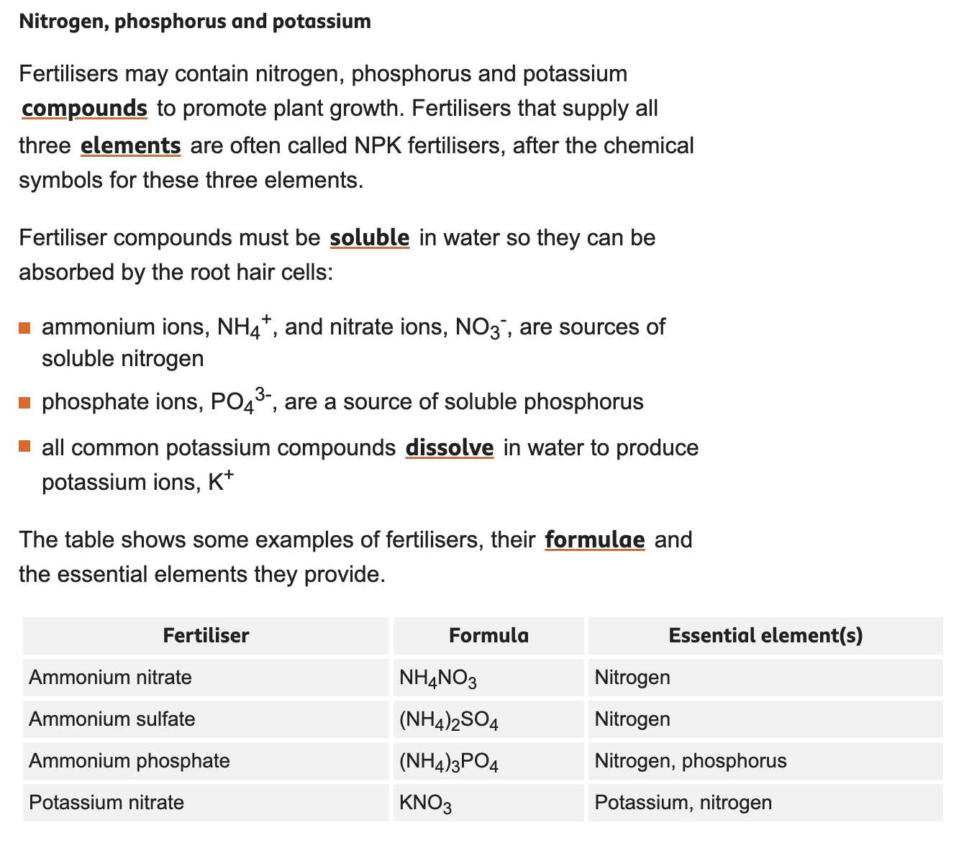

**10.3 Air quality and climate**

1. State the composition of clean, dry air as approximately 78% nitrogen, N2, 21% oxygen, O2 and the remainder as a mixture of noble gases and carbon dioxide, CO2
2. State the source of each of these air pollutants, limited to:

(a)  carbon dioxide from the complete combustion of carbon-containing fuels

(b)  carbon monoxide and particulates from the incomplete combustion of carbon-containing fuels

(c)  methane from the decomposition of vegetation and waste gases from digestion in animals

(d)  oxides of nitrogen from car engines

(e)  sulfur dioxide from the combustion of fossil fuels and factory smoke which contain sulfur compounds

1. State the adverse effect of these air pollutants are limited to:

(a)  carbon dioxide: higher levels of carbon dioxide leading to increased global warming, which leads to climate change

(b)  carbon monoxide: toxic gas that binds to hemoglobin in the blood reducing the ability to carry oxygen in the blood. Causes fatigue, headaches, dizziness etc.

(c)  particulates: increased risk of respiratory problems (asthma, pulmonary diseases) and lung cancer

(d)  methane: higher levels of methane leading to increased global warming, which leads to climate change

(e)  oxides of nitrogen: acid rain, photochemical smog and respiratory problems

(f)  sulfur dioxide: acid rain

1. State and explain strategies to reduce the effects of these environmental issues, limited to:

(a)  climate change: planting trees, reduction in livestock farming, decreasing use of fossil fuels, increasing use of hydrogen and renewable energy, e.g. wind, solar, tidal etc.

(b)  acid rain: use of catalytic converters in vehicles, reducing emissions of sulfur dioxide by using low-sulfur fuels and flue gas desulfurisation with calcium oxide

9. Explain how oxides of nitrogen form in car engines and describe their removal by catalytic converters, e.g., 2CO + 2NO → 2CO2 + N2

5. Describe photosynthesis as the reaction between carbon dioxide and water to produce glucose and oxygen in the presence of chlorophyll and using energy from light

6. State the word equation for photosynthesis, carbon dioxide + water → glucose + oxygen

7. State the symbol equation for photosynthesis, 6CO2 + 6H2O → C6H12O6 + 6O2

8. Describe how the greenhouse gases carbon dioxide, ammonia, and methane cause global warming, limited to:

(a) the absorption, reflection and emission of thermal energy

(b) reducing thermal energy loss to space

