**Atoms and Molecules**

Pure substances: that only contains one substance. Elements and compounds

Atom – basic/ smallest unit of matter.

Molecule- a group of atoms bonded together.

Element – simple pure substance that cannot be broken down into smaller parts or another substance. It contains protons, neutrons, and electrons. E.g., potassium, hydrogen

Compound- a substance made up of two or more different elements chemically combined/ reacted/bonded together in a fixed ratio. E.g., HCl, NaOH, NH3

Mixture- a substance made up of two or more different chemical elements that are not chemically involved only physically together. Different states of matter cold coffee E.g., air mixture of hydrogen, nitrogen, and oxygen.

Proton = atomic number

proton and electron number/ value are same except for isotopes

Neutrons atomic mass - proton number

<https://youtu.be/tgPo9sUhcs4>

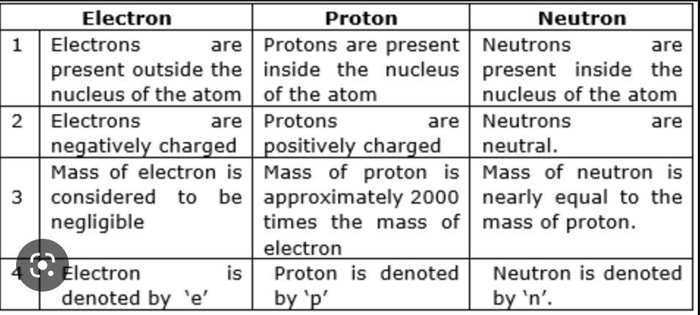

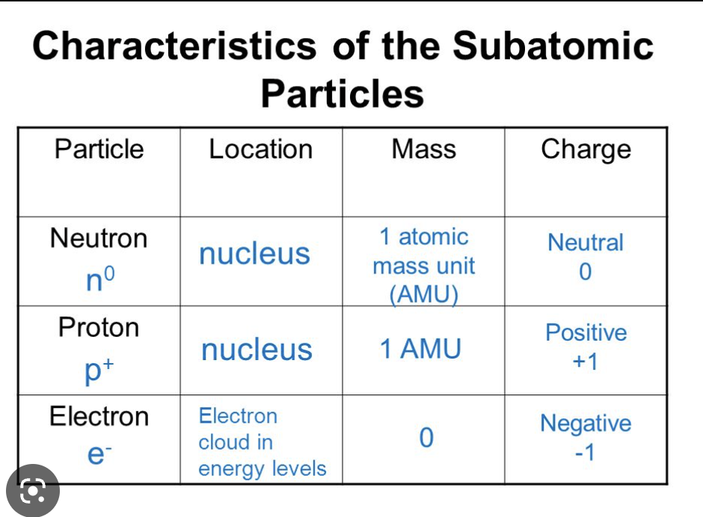

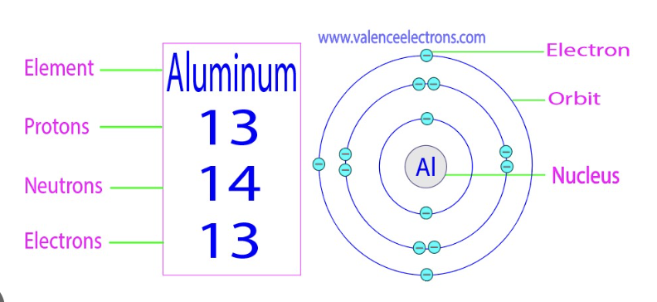

Atomic mass = proton number = electron number

Molecular mass – atomic mass = neutron number

Chemical symbol- to represent an electron we use a chemical symbol such as N for nitrogen and Zn for zinc.

