States of matter or kinetic particle theory/model of matter

**The particulate nature of matter**

1. State the distinguishing properties of solids, liquids and gases
2. Describe the structure of solids, liquids and gases in terms of particle separation, arrangement and types of motion
3. Explain changes of state in terms of the kinetic particle theory and the energy changes involved
4. Describe and explain diffusion in terms of the movement of particles (atoms, molecules or ions)
5. Describe and explain dependence of rate of diffusion on molecular mass

**Experimental techniques**

Name and suggest appropriate apparatus for the measurement of time, temperature, mass and volume, including burettes, pipettes and measuring cylinders

What are the states of matter?

Arrangement of particles

**What is matter?**

What is kinetic particle model or theory of matter?

Why are gases compressible? Gas particles have spaces in between which is why they can be compressed.



If particles gain or lose energy, they change their state.

If they gain energy, then they turn into liquids or gases.

If they lose energy, they either convert into liquids or solids.

Their motion

Forces of attraction

Particles arrangement

Solid to liquid melting – particles gain energy, start moving faster, they start moving randomly, lose forces of attraction, randomly arrange themselves, they change their state to a liquid.

1. What is the process of evaporation? Liquid to gases. E.g hanging wet clothes and they dry after some time.

Liquid particles gain kinetic energy, increase movements, move further apart, forces of attraction decrease that particles leave the surface of the object. They turn into gas.

1. What is the process of condensation? Gas to liquid

e.g car windows, after a hot shower the mirror turns blurry that is due to condensation.

Gas particles lose kinetic energy, they cool down, forces of attraction increase, move closer together, turn into liquid.

1. What is process of freezing? Liquid to solid

Liquid particles lose kinetic energy, cool down, move closer together, and turn into a solid.

1. What is the process of sublimation? Gas to solid
2. What is the process of boiling? Liquid to gas

What is the difference between evaporation and boiling?

In evaporation any given temperature

Particles leave the surface.

In boiling particles change state at a certain temperature the boiling point for eg 100 C for water

All particles gain energy and leave the container.

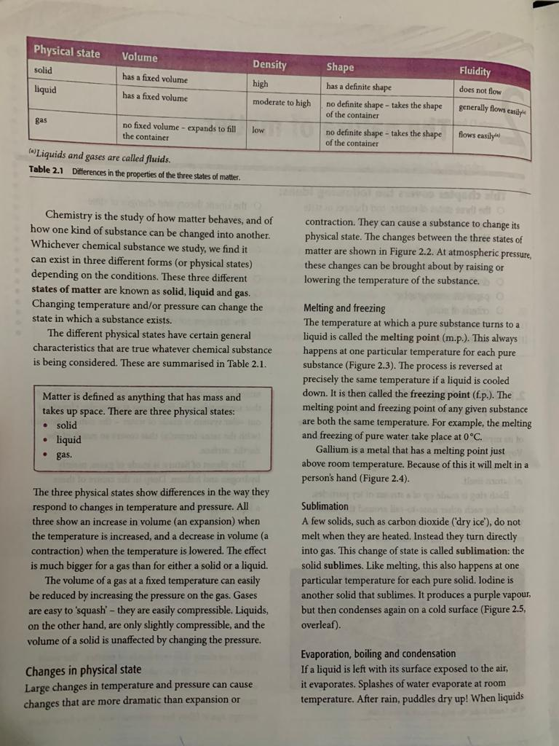

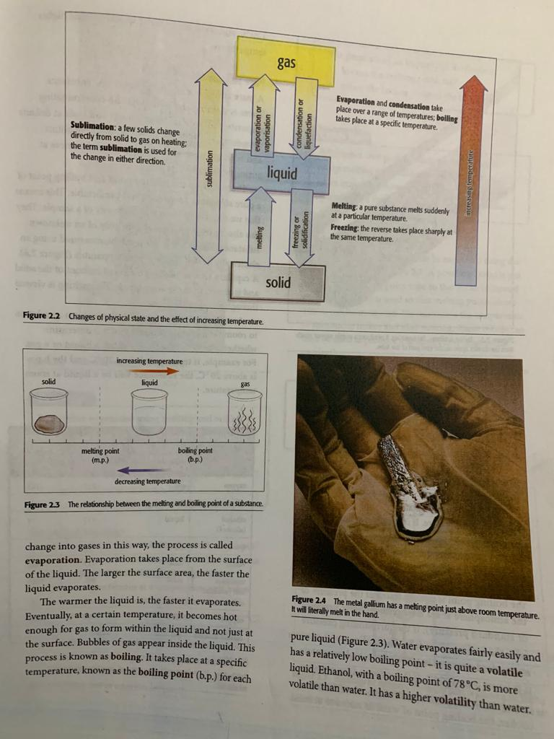

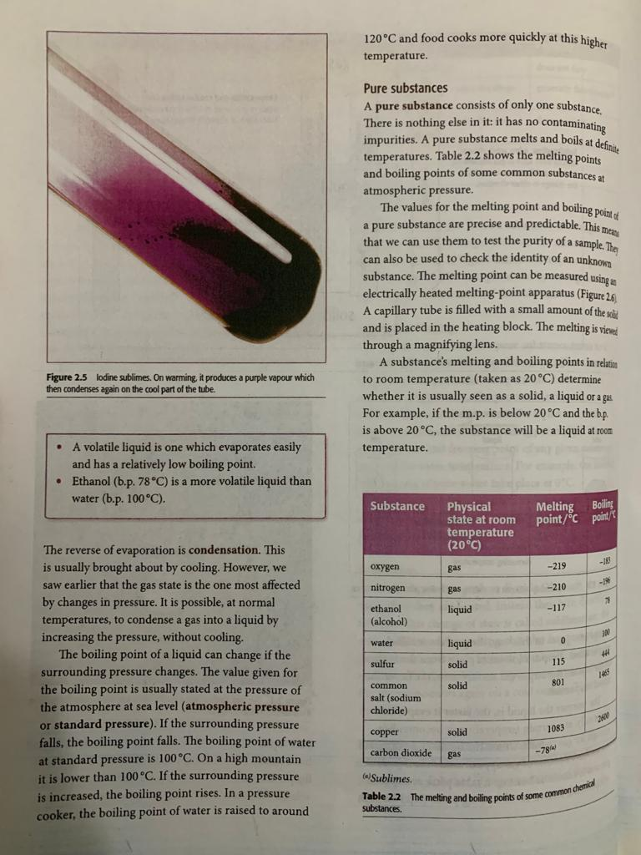

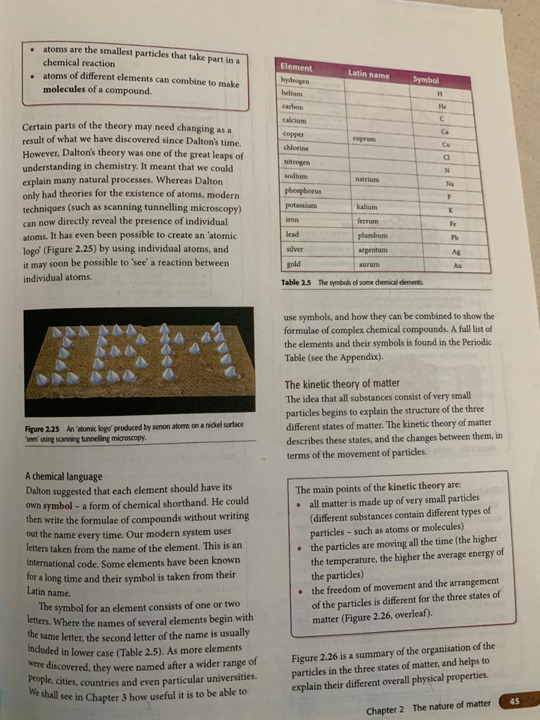

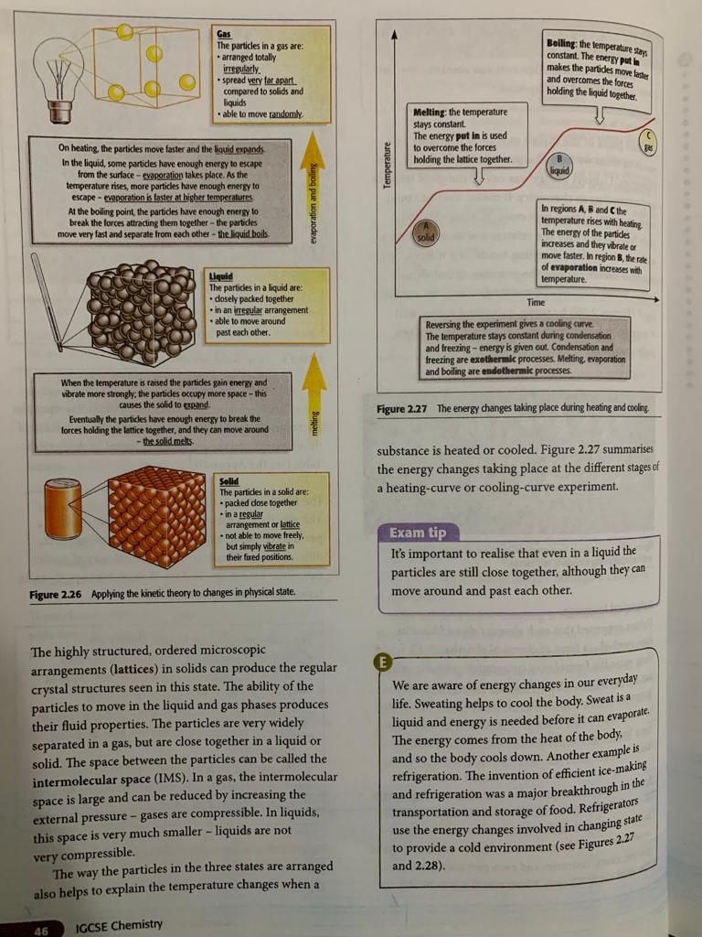

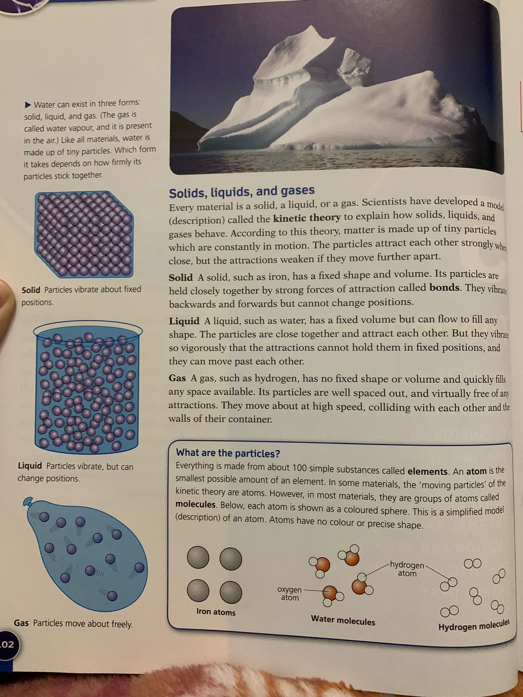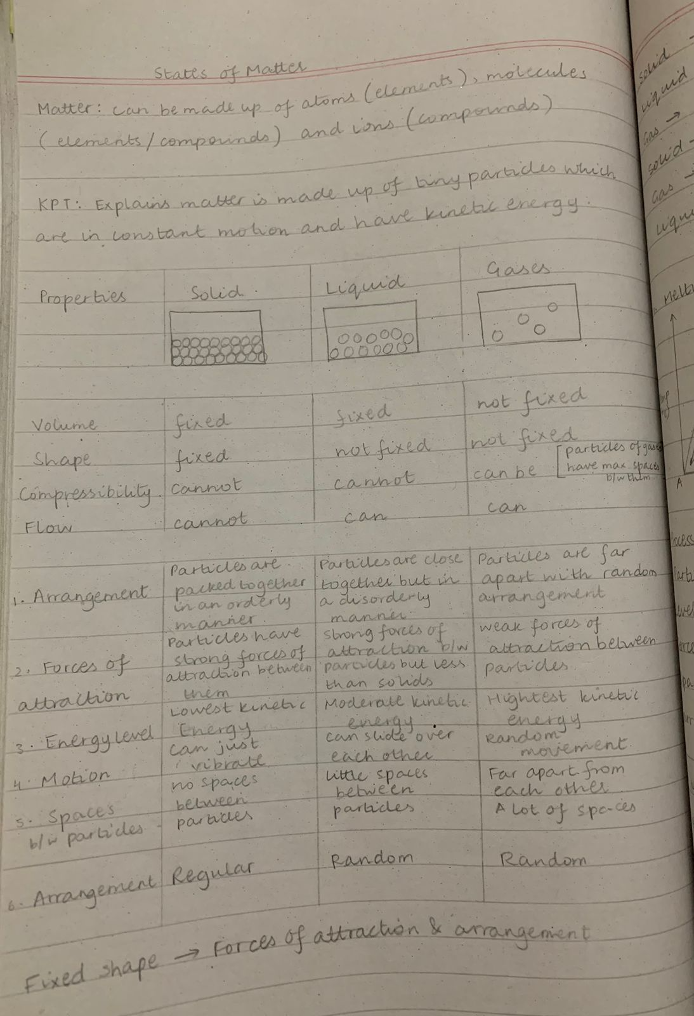



Solid particles are vibration about their position

