*Group behaviour in organisations*

*Group development and roles*

Tuckman’s **stages of group development** (1965). five stage group formation process

(forming – storming – norming – performing – adjourning)

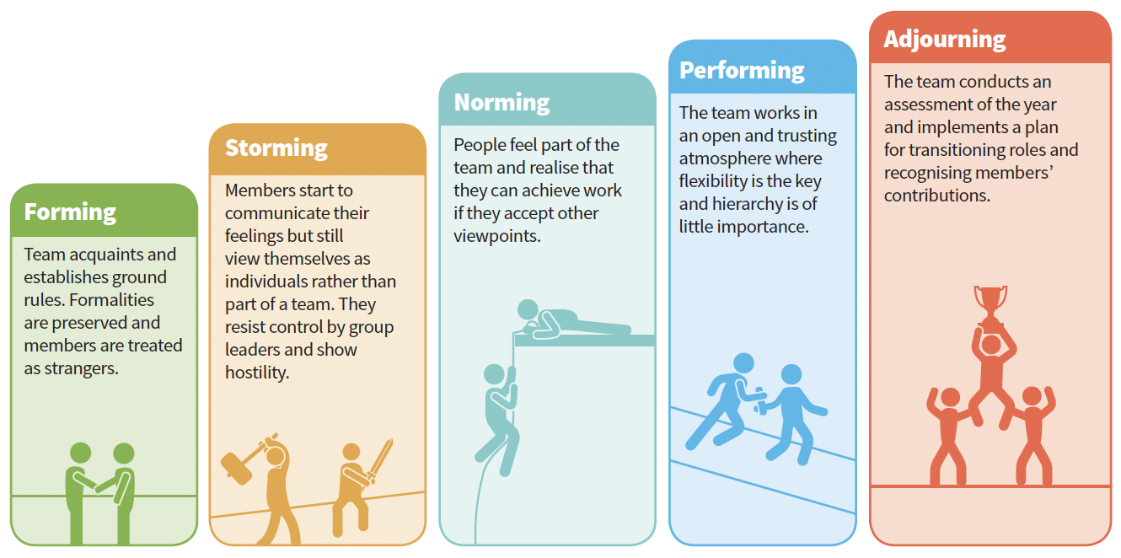

**Belbin’s Theory of Team Roles**

Belbin’s Theory of Team Roles (1981) takes a slightly

different approach to understanding group behaviour.

Belbin proposes that an ideal team contains people who

are prepared to take on different roles.

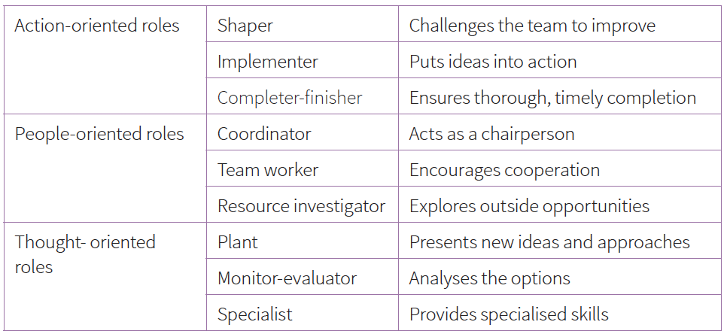

**Action-oriented roles**

Shapers are people who challenge the team to improve. They are dynamic and usually extroverted people who enjoy stimulating others, questioning established views and finding the best approaches for solving problems.

Shapers tend to see obstacles as exciting challenges,

although they may also be argumentative and upset

colleagues. Implementers are the people who get things

done. They turn the team’s ideas and concepts into

practical actions and plans. They tend to be people who

work systematically and efficiently and are very well

organised. However, they can be inflexible and resistant

to change. Completer-finishers are the people who see

that projects are completed thoroughly. They ensure there have been no mistakes and they pay attention to the smallest of details. They are very concerned with deadlines and will push the team to make sure the job is completed on time. They are described as perfectionists and may worry unnecessarily and find it hard to delegate.

**People-oriented roles**

Coordinators are the ones who take on the traditional

team-leader role and guide the team to the objectives. They

are often excellent listeners and they are naturally able to

recognise the value that each team member brings to the

table. They are calm and good-natured, and delegate tasks

very effectively. Their potential weaknesses are that they

may delegate too much personal responsibility, and may

be manipulative. Team workers are the people who provide

support and make sure that people within the team are

working together effectively. These people are negotiators

and are flexible, diplomatic and perceptive. These tend to

be popular people who prioritise team cohesion and help

people get along. They may be indecisive and struggle to

commit to a position. Resource investigators are innovative

and curious. They explore the available options, develop

contacts and negotiate for resources on behalf of the

team. They are enthusiastic team members, who identify

and work with external stakeholders to help the team

accomplish its objective. They are outgoing and people

generally respond positively to them. However, they may

lose enthusiasm quickly.

**Thought-oriented roles**

The plant is the creative person who comes up with new

ideas. They thrive on praise but struggle to take criticism.

Plants are often introverted and prefer to work on their

own. Their ideas can sometimes be impractical and they

may also be poor communicators. Monitor-evaluators

are good at analysing and evaluating the ideas that other

people propose. These people are shrewd, objective and

strategic and they carefully weigh the pros and cons of all

the options before coming to a decision. They can be seen

as detached or unemotional. Specialists are people who

have specialised knowledge that is needed to get the job

done. They pride themselves on their skills and expertise

but may sometimes focus on technicalities at the expense

of the bigger picture.

**Measuring team roles**

**The Belbin Test** is a test for assessing team roles. There are a

number of these tests and you need to pay to access them.

Paying to take the test produces a very detailed report of

your skills and abilities in relation to the team roles already

discussed such as advice on where you may be most

comfortable, roles you may be best (or least) suited to and

strategies for playing to your strengths.

**Evaluation**

Tuckman’s model of group formation is extremely useful

in providing guidance on how groups form and in allowing

organisations to see that these stages are part of the

normal developmental processes. However, this model

was originally proposed as an explanation of small groups

and may not be as useful in helping to understand the

development of larger groups. Tuckman does not provide

guidance on timescales for moving from one stage to

another and neither does he recognise that group formation

is often cyclical rather than linear. Despite these and

other criticisms his work has been extremely influential in

understanding the stages that groups pass through. One final point is that he does not take account of the differing team roles that group members might have to adopt,

which is where Belbin steps in.

Rather than looking at the stages of group development, Belbin examines the type

of people that are required in a group. This means that an

important application of his work (and an important part

of the development of a group) is to assess the preferred

roles of each team member and to encourage all members

to appreciate the characteristics and the strengths of the

others. Of course, one problem when looking at Belbin’s

team roles is that many groups may be smaller than nine.

Belbin recognised this himself and, in practice, group

members in small groups will often take on more than one

role. Unfortunately much of the research into Belbin’s team

roles suggests that many management teams have too many

implementers and shapers and not enough plants and team

workers. This is likely to mean that plans are formulated and

given detail fairly quickly, but that they may lack creativity

and may alienate some members (Arnold et al., 2005).

However Belbin must be given credit for his focus on the

need for diversity within teams and the value of different

characteristics and skills.

**The decision making process**

It is widely assumed that people make rational,

reasonable and logical decisions. This assumption rests

on a further assumption – that people making decisions have access to complete and accurate information and that they can process this without bias.

**Wedley and Field (1984**) describe the **pre-planning**

**stage** of the decision making process and the decisions

that are taken before beginning to solve a problem.

These include **deciding which type of leadership to use**,

**whether to involve others, how to gather information,**

**what people to contact and how to generate alternatives**.

These are not the end decisions but are important ‘predecisions’

that need to be considered. Wedley and Field

suggest that once the decision making process has been

started, it is difficult to stop and this may lead to poor

decisions being taken. They propose that for greater

flexibility, managers should be encouraged to pre-plan

the decision making process.

They identify a set of **problem-solving stages** that is widely

considered to be logical and rational. However,

it is unlikely that every decision making situation will fit

this model: there may be time pressures, there may be information missing and so on. A decision support system (DSS) is a computer-based system that supports decision

making activities.

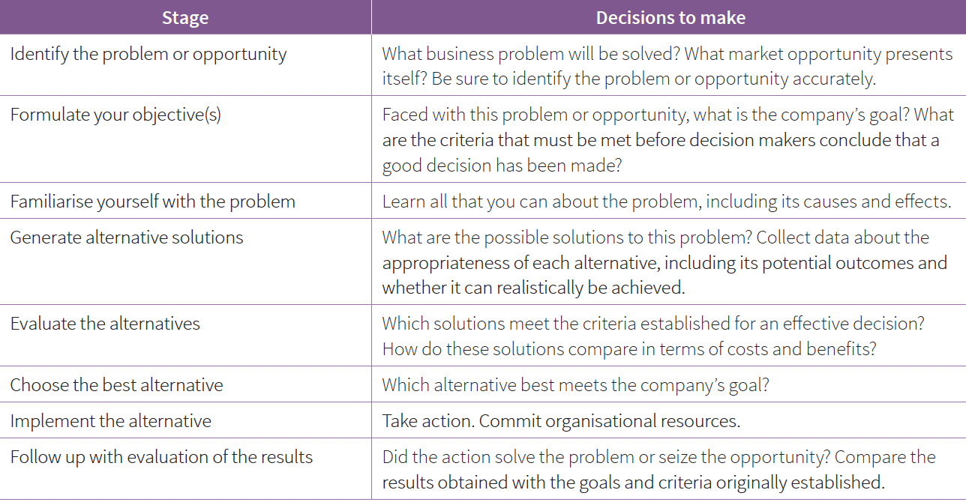

**Groupthink**

Groupthink is defined as a psychological phenomenon

that occurs within a group of people, in which the desire for

harmony or conformity in the group results in an irrational

or dysfunctional decision-making outcome. In other words,

the group creates a situation in which a decision is made

which would not have been made by individuals.

**Janis (1971)** identified eight different “symptoms” that indicate groupthink and these are:

1 Illusions of invulnerability. This means that members

of the group believe that they can do no wrong and

can never be in any sort of trouble. This can lead to

overly optimistic thinking about likely outcomes and encourages risky decision making.

2 Unquestioned beliefs. A lack of questioning,

particularly from a legal, financial, or moral/ethical standpoint, can

prevent group members from considering all the

possible consequences of their decisions.

3 Rationalising. This is where group members ignore

warning signs and assume that everything will be

alright.

4 Stereotyping. Group decision making can involve

stereotypical views of those who raise issues or point

out problems. This can mean that they are ignored or

labelled as members of an ‘out-group’.

5 Self-censorship. In a group situation we are less likely

to listen to our own doubts or misgivings as it appears

to us that no-one else has any doubts or misgivings.

This is a little like the ‘pluralistic ignorance’ seen in

bystanders to an accident when they assume that,

since no-one else is responding, that there is no real

emergency. In this way, everyone is convinced that

there is nothing to worry about.

6 Mind guards. Janis described these as ‘self-appointed

censors to hide problematic information

from the group’. We don’t want the rest of the group

to see that we are worried and so we hide this.

Unfortunately, if everyone is feeling the same way

and hiding their feelings, this can lead to some very

risky decisions.

7 Illusions of unanimity. Groups behaving in the ways

that we have just considered will produce the illusion of

‘unanimity’ or agreement.

8 Direct pressure to conform. Groups can place

dissenters (those who disagree) or those who question

under a great deal of pressure, in some cases making

them appear as though they are being disloyal or

traitorous by asking questions.

**Strategies to reduce the risk of groupthink**

To reduce the risk of groupthink, leaders need to give group

members the opportunity to express their own ideas or

argue against ideas that have already been proposed.

Breaking up members into smaller independent teams can

also be helpful. The leader should avoid stating their views

too forcefully, especially at the start of the discussion, to

ensure that people are able to develop their own views first.

If someone is instructed to take the role of ‘devil’s advocate’,

that is to deliberately present the opposing view regardless

of their own personal viewpoints, this can also reduce the likelihood of groupthink occurring and encourage the group members to take a critical perspective.

**Cognitive limitations and errors**

Individuals in a group decision making setting are often

functioning under substantial cognitive demands. As a

result, cognitive and motivational biases can often affect

group decision-making adversely. **Forsyth (2006**) suggests

that there are **three categories of potential biases** that may affect group decision making.

The first is called **‘Sins of Commission’** and refers to the

misuse of information in the decision making process. This

may involve the use of information in the decision making

process that has already been shown to be inaccurate (belief

perseverance). Alternatively, it may be shown by group

members remaining committed to a plan because some

investment of time or money has already been made even

though this plan may now be obviously flawed (sunk cost

bias). If a group chooses to use information despite having

been told to ignore it then they are guilty of extra-evidentiary

bias and, finally, falsely overestimating the importance of

past knowledge or experience is termed hindsight bias.

The second category of bias is ‘**Sins of Omission’** and this is

overlooking key information. This can include base rate bias

which would be overlooking very basic relevant information.

The fundamental attribution error is made when members

of a group make decisions based on inaccurate appraisals of

an individual’s behaviour.

The third category is **‘Sins of Imprecision’** and this involves

relying too heavily on heuristics that over-simplify complex

decisions. Heuristics include the availability heuristic (overreliance

on the information that is most easily and readily

available), the conjunctive bias (failing to consider relationships

between events) and the representativeness heuristic (where

group members rely too heavily on decision making factors

that may appear meaningful but are, in fact, misleading).

ISsUES AND DEBATES

Understanding the process of decision making is

clearly very useful and will have obvious applications

to any organisation. Wedley and Field not only explain

the process of decision making but identify several

strategies to ensure that poor decisions are avoided.

These include the use of pre-planning as well as the use

of computer-based decision support systems. Janis’s

exploration of groupthink is also useful and can be

applied in organisations to ensure that the negative

outcomes of groupthink are avoided. It is important to

remember that groupthink can sometimes be extremely

useful, allowing for big decisions to be taken quickly

and easily, but that there are also pitfalls. The strategies

outlined above should be common practice in any

organisation where decision making occurs regularly.

Forsyth examines cognitive limitations and errors

in even more detail and knowledge of these biases

would be valuable information within an organisation

that takes decisions frequently. Acknowledging and

recognising the possibility of these errors will allow an

organisation to take steps to reduce them.

**Levels and causes of group conflict**

There are several types of conflict that can occur inorganisational contexts. These include:

• Intra-group conflict: when people within the same group

are in conflict.

• Inter-group conflict: conflict between two groups within

the same organisation.

• Inter-individual conflict: conflict between two or more

individuals within a group.

**Positive and negative effects of conflict**

Conflict can have both positive and negative effects.

Some of the positive effects of conflict have been

identified by **Pruitt and Rubin (2003).** They suggest

that it is conflict which produces change and this

may be particularly true of small organisations where

change can be more easily implemented than in

large organisations. The resolution of conflict may

also strengthen **group unity and commitment** **to**

**organisational goals** or to groups within the organisation

(remember that the ‘storming’ phase of group formation

was a necessary stage). Conflict can help to ensure that

decisions are fully considered and explored and may

prevent ‘risky’ decision making such as **groupthink, and**

**may also produce creative and innovative suggestions**.

Conflict can take the form of **healthy competition** such

as sales staff competing for the highest sales of the

month or the year and this can have positive effects on

total revenue. However, management should be cautious

about using competition as a means of increasing

motivation as there are several possible negative effects

that need to be considered.

**Conflict can distract workers from their jobs, reducing**

**overall productivity and can waste time, resources**

**and money**. **Goals can become distorted** as people

become more focussed on the conflict than on their

jobs. Conflict can have significant effects on the **physical**

**and psychological health** of the people involved,

increasing **absenteeism and turnover and reducing staff**

**satisfaction**. If people feel that the conflict includes

any behaviours that could be described as **bullying**

**or harassment**, this would need to be referred to the

Human Resources department and if made public, could

have extremely negative effects on the public perception

of the company.

**Managing group conflict**

**Thomas (1976)** suggests five strategies that can be used to manage group conflict:

• Competition: individuals may persist in conflict until

someone wins and someone loses. At this point, the

conflict is over.

• Accommodation: here one individual will need to make

a sacrifice in order to reduce the conflict. This can be

extremely effective in reducing conflict and preventing

further damage to the relationship.

• Compromise: each group or individual under conflict

must make some compromise and give up something

to reduce the conflict. This will be effective only if both

sides lose comparable things.

• Collaboration: the group has to work together to

overcome the conflict.

• Avoidance: avoidance involves suppressing the conflict

or withdrawing from the conflict completely. This does

not resolve the conflict which is still there and has not

been addressed. This can be effective in creating a

cooling-off period.